**IHCI Week-4 Tutorial Activity**

**Rules :**

– Submit a **Google Doc**, NOT a PDF or a Google slide.

– Use the default fonts, line spacing, and font size unless specifically required in the assignment.

- After you submit the Google Doc, it will be automatically locked, and you will be unable to make any changes.

– Standard plagiarism rules apply

– Your submission will not be considered for grading or feedback if you do not follow these guidelines.

**Name : Krishna Shukla**

**Roll No. : 2022254**

**HCI Group No. 13**

**Pre-Req : Miro Boarding tool** (<https://miro.com/>)

**Activity**

1. **For this activity, you will be creating different personas based on different categories of user bases you were able to identify (3 - 4 personas). Please refrain from using pictures without others consent, you can explore AI generated pictures**(<https://generated.photos/faces>).

**Examples:**

**NOTE:** *Template attributes can vary from the examples; attributes should be selected based on the IHCI problems and other factors****.***

1. **And based on the personas you created, create a Multiple user based Empathy Map depicting different aspects of users.**

**Examples:**

**Answers:**

**Insert your different personas Pictures (provide link to slides if possible) :**

**Link to Slides:**[hci](https://docs.google.com/presentation/d/1Xfc2Xk4UaJCBW7o0zoDDtTGPFi-t8kjLStDjOmXIMtk/edit?usp=sharing)

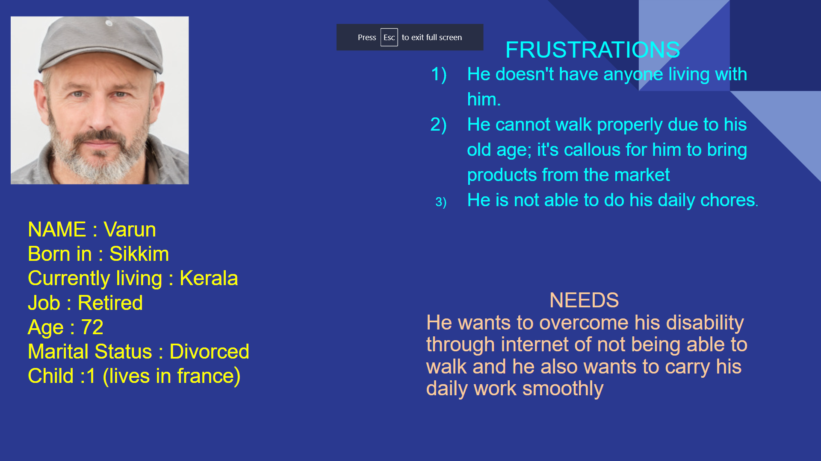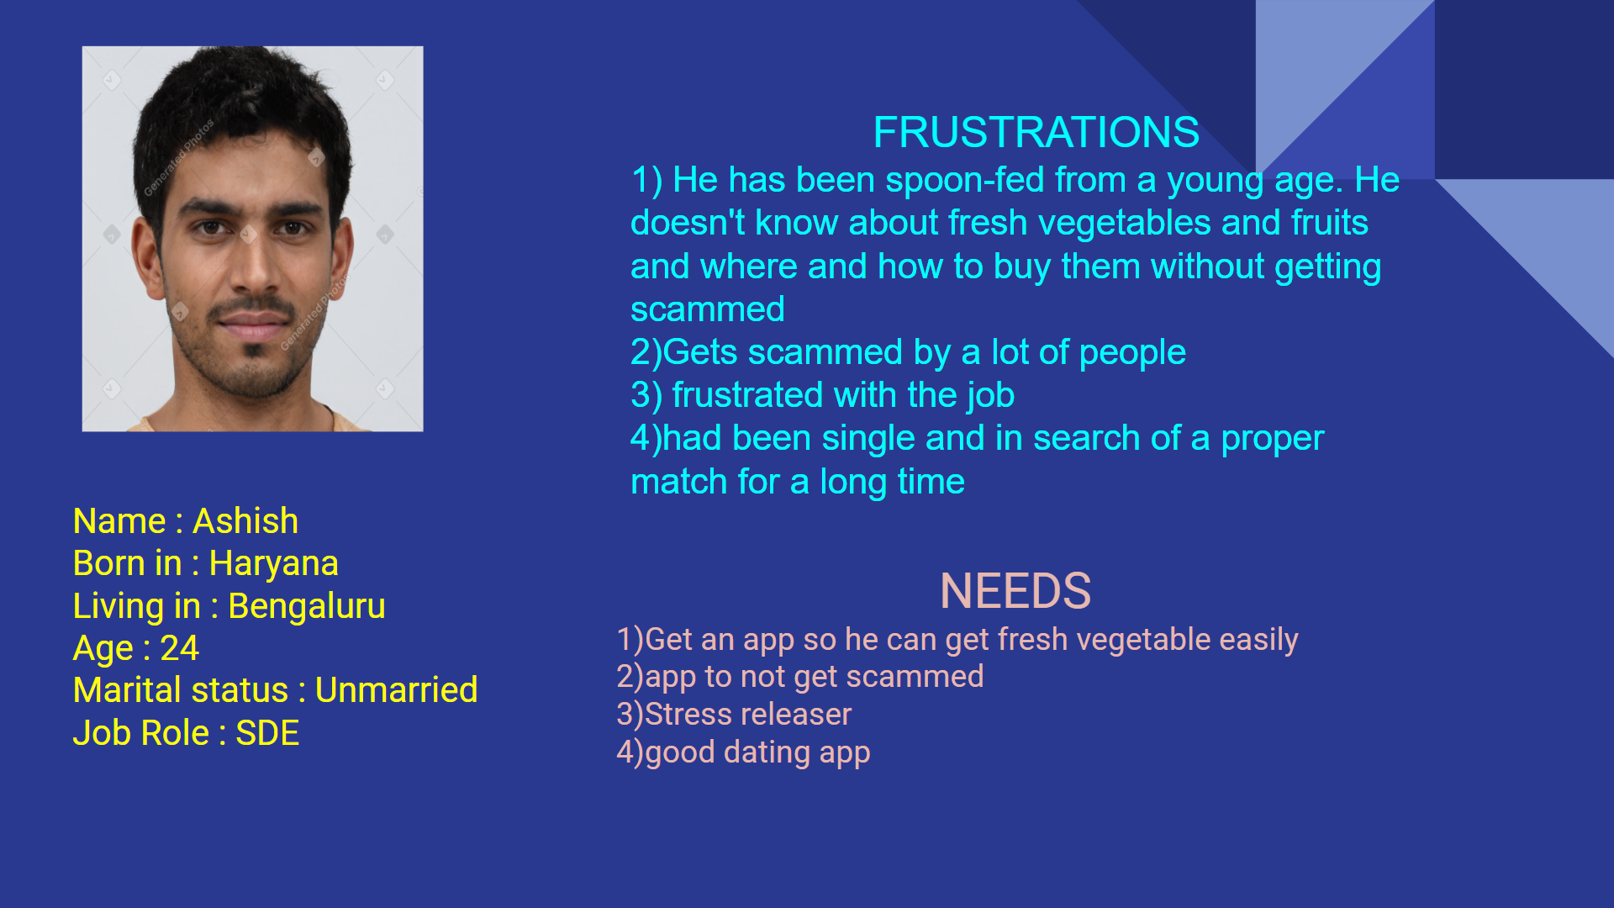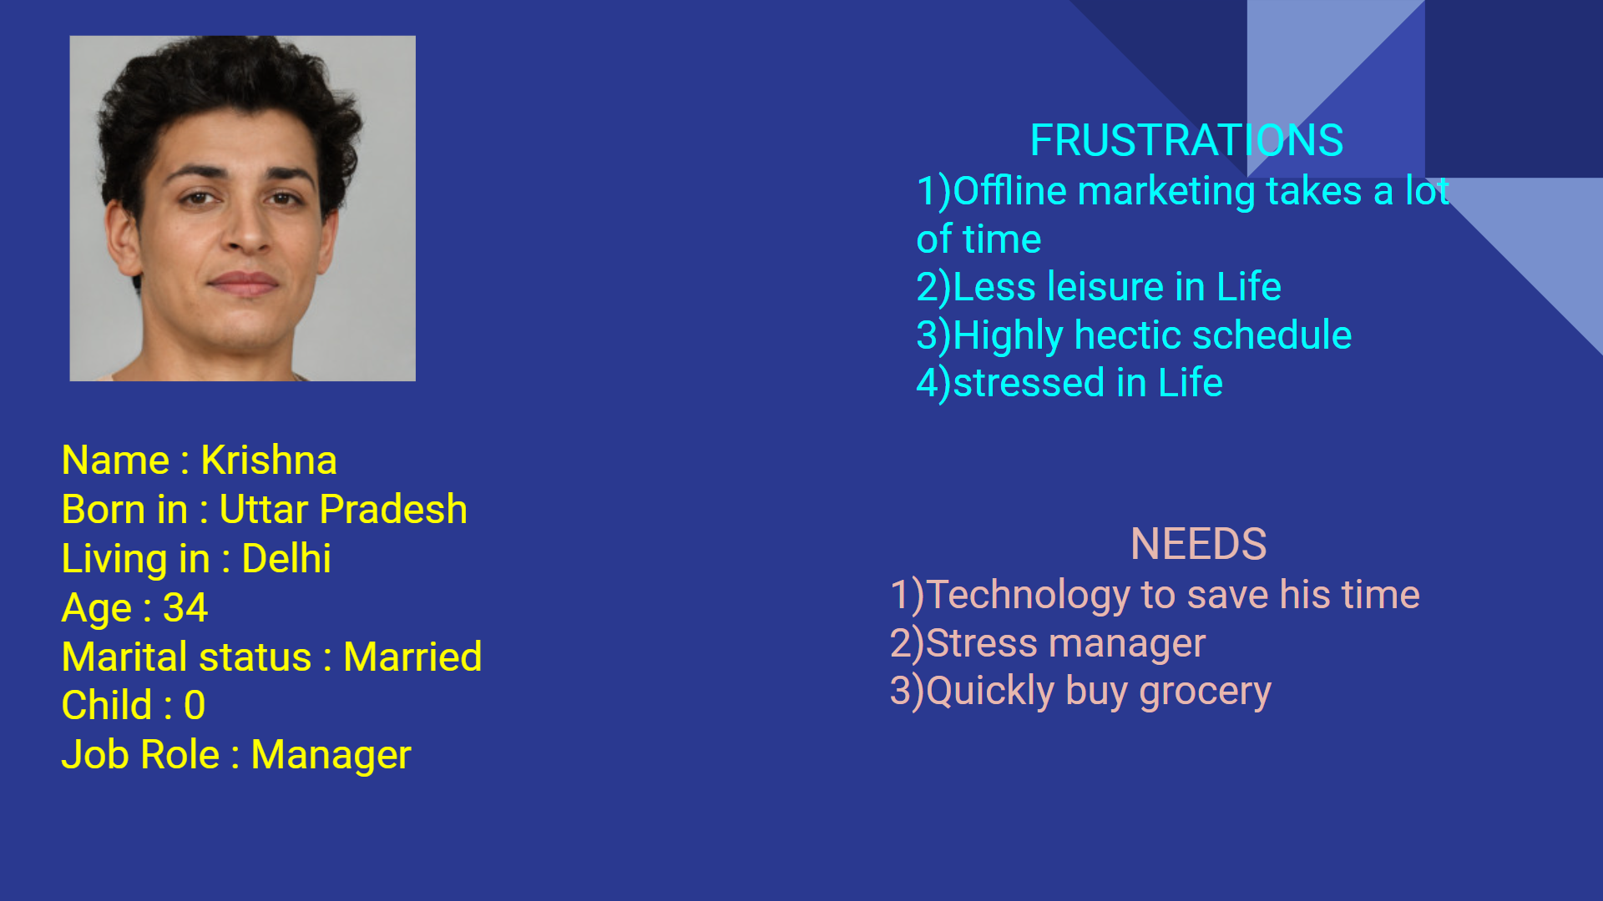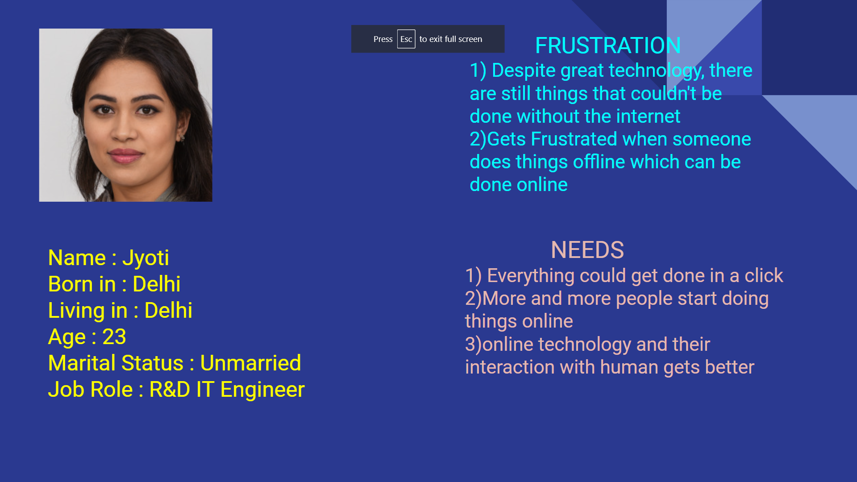

**Insert your Empathy Mapping Picture (and provide Miro link) :**

Link to miro: <https://miro.com/app/board/uXjVP9DE0Ds=/?share_link_id=828341558591>

